ASSIGNMENT -2

Q1. Find output of this code. Let input 2,3,6

Ans.

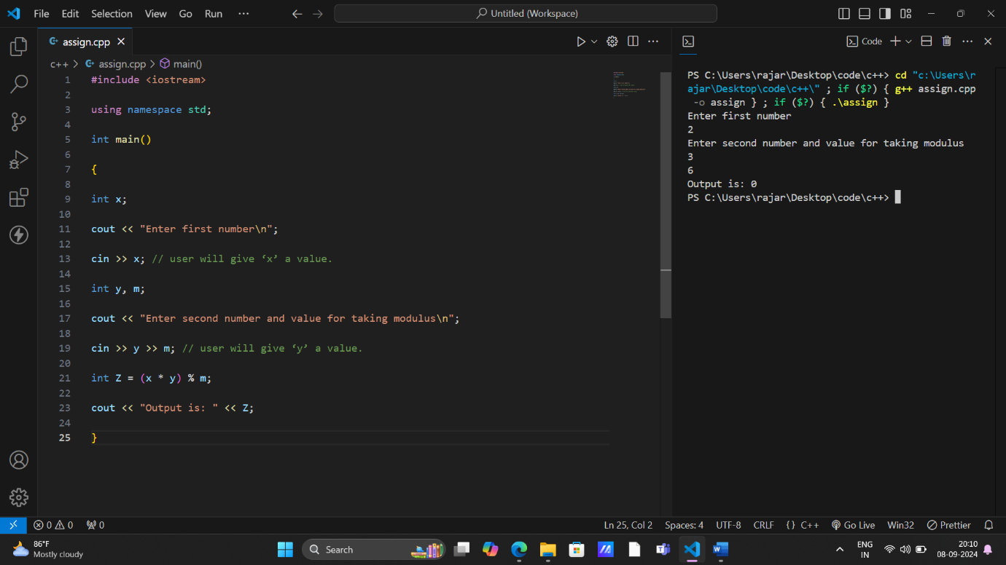

OUTPUT- 0

Q2. Find output of this code. Let input 3,2.

Ans.

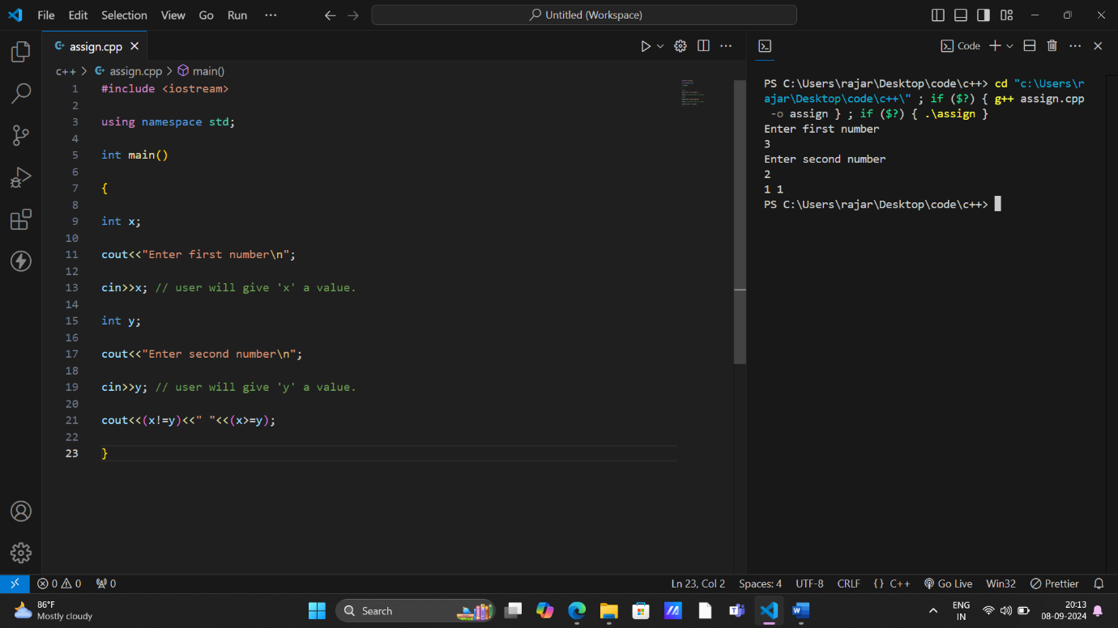

OUTPUT- 1 1

Q3. Find the output of this code. Let input 2,3.

Ans.

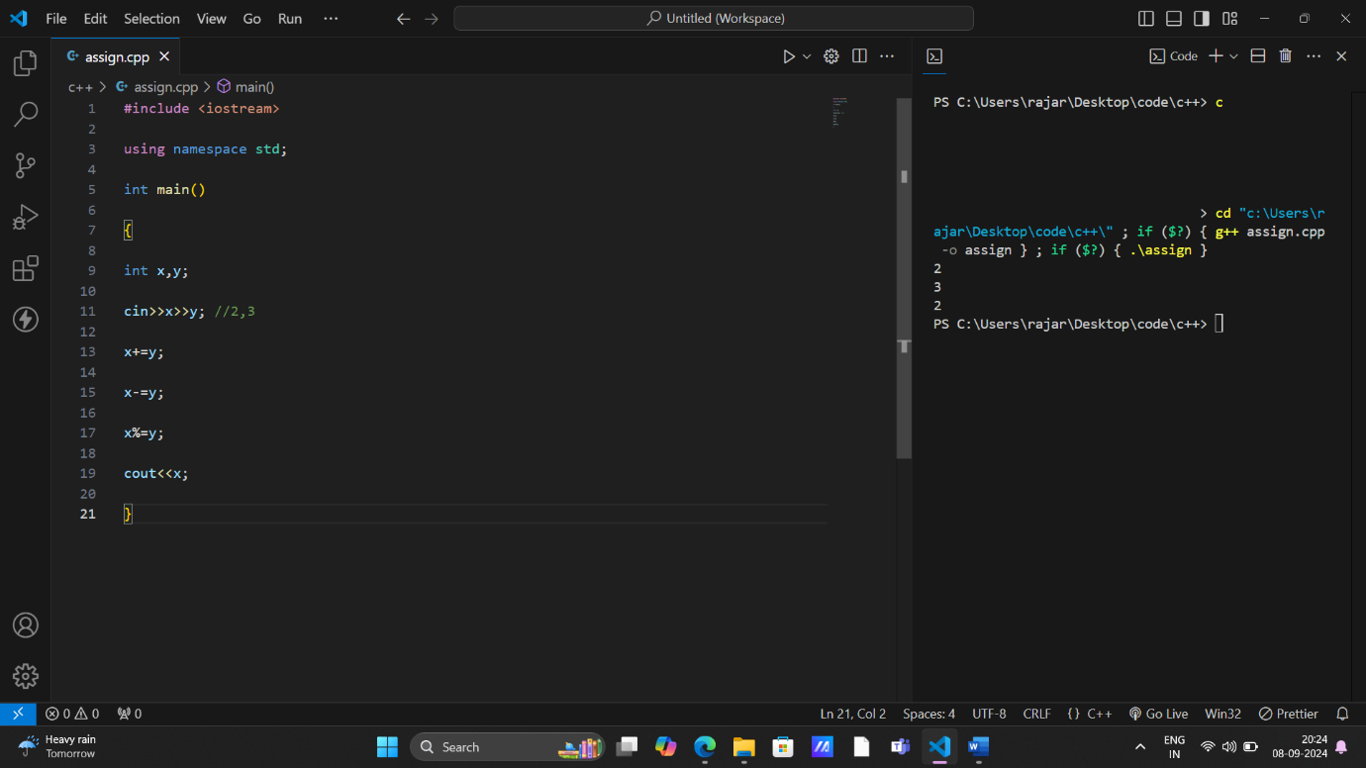

OUTPUT- 2

Q4. WAP to print volume of sphere with height and length as inputs.

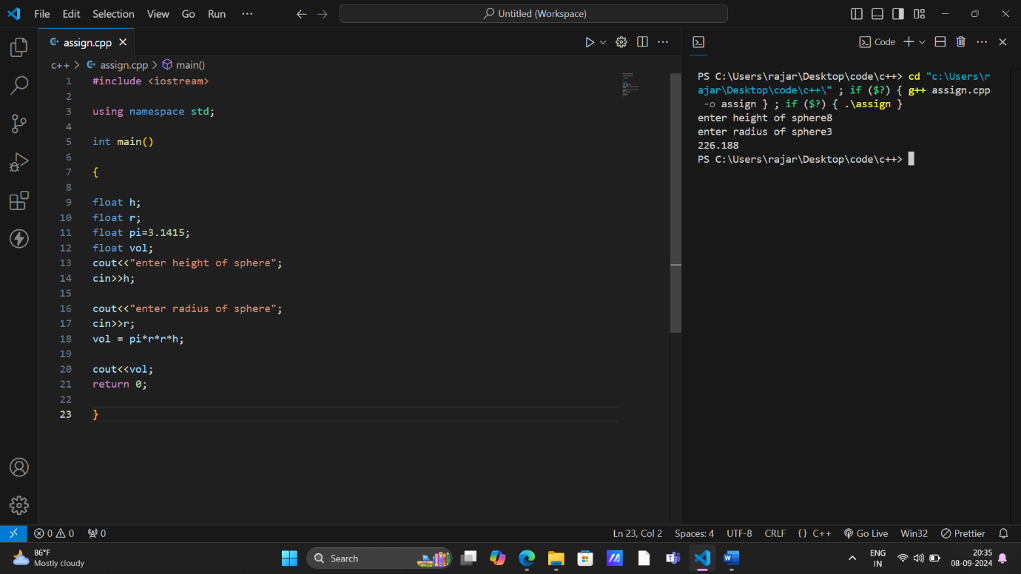

Q5. WAP to find the difference between ASCII of two characters, take them as input.

Ans.

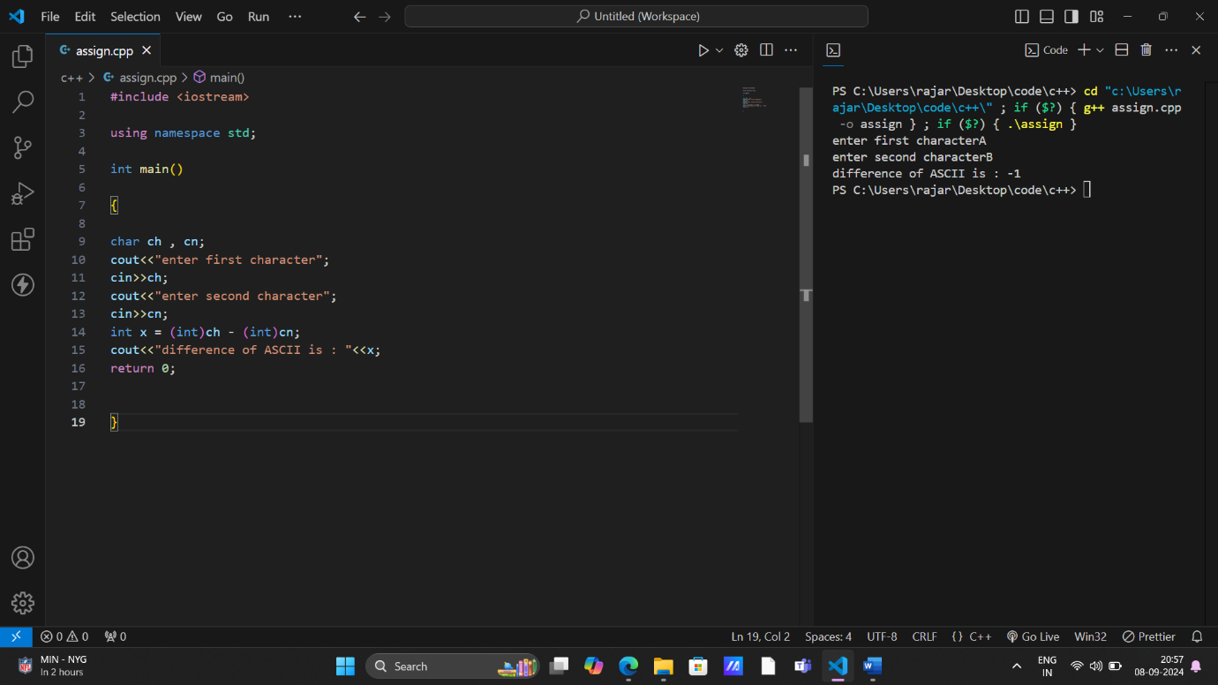

Q6. Find the output of below code.

Ans.

